**Introduction**

When building a machine learning model in real-life, it’s almost rare that all the variables in the dataset are useful to build a model. Adding redundant variables reduces the generalization capability of the model and may also reduce the overall accuracy of a classifier. Furthermore adding more and more variables to a model increases the overall complexity of the model.

As per the ***Law of Parsimony*** of ‘*Occam’s Razor’*, the best explanation to a problem is that which involves the fewest possible assumptions. Thus, feature selection becomes an indispensable part of building machine learning models.

## Feature Engineering Definition

Feature engineering refers to the process of using domain knowledge to select and transform the most relevant variables from raw data when creating a predictive model using machine learning or statistical modeling. The goal of feature engineering and selection is to improve the performance of machine learning (ML) algorithms.

## What is Feature Engineering?

The feature engineering pipeline is the preprocessing steps that transform raw data into features that can be used in machine learning algorithms, such as predictive models. Predictive models consist of an outcome variable and predictor variables, and it is during the feature engineering process that the most useful predictor variables are created and selected for the predictive model.

Feature engineering consists of creation, transformation, extraction, and selection of features, also known as variables, that are most conducive to creating an accurate ML algorithm. These processes entail:

* Feature Creation: Creating features involves identifying the variables that will be most useful in the predictive model. This is a subjective process that requires human intervention and creativity. Existing features are mixed via addition, subtraction, multiplication, and ratio to create new derived features that have greater predictive power.
* Transformations: Transformation involves manipulating the predictor variables to improve model performance; e.g. ensuring the model is flexible in the variety of data it can ingest; ensuring variables are on the same scale, making the model easier to understand; improving accuracy; and avoiding computational errors by ensuring all features are within an acceptable range for the model.
* Feature Extraction: Feature extraction is the automatic creation of new variables by extracting them from raw data. The purpose of this step is to automatically reduce the volume of data into a more manageable set for modeling. Some feature extraction methods include cluster analysis, text analytics, edge detection algorithms, and principal components analysis.
* Feature Selection: Feature selection algorithms essentially analyze, judge, and rank various features to determine which features are irrelevant and should be removed, which features are redundant and should be removed, and which features are most useful for the model and should
* be prioritized.

## Steps in Feature Engineering

The art of feature engineering may vary among [data scientists](https://www.omnisci.com/role/omnisci-for-data-scientists" \t "_blank), however steps for how to perform feature engineering for most machine learning algorithms include the following:

* Data Preparation: This preprocessing step involves the manipulation and consolidation of raw data from different sources into a standardized format so that it can be used in a model. Data preparation may entail data augmentation, cleaning, delivery, fusion, ingestion, and/or loading.
* Exploratory Analysis: This step is used to identify and summarize the main characteristics in a data set through data analysis and investigation. [Data science](https://www.omnisci.com/learn/data-science" \t "_blank) experts use data visualizations to better understand how best to manipulate data sources, to determine which statistical techniques are most appropriate for data analysis, and for choosing the right features for a model.
* Benchmark: Benchmarking is setting a baseline standard for accuracy to which all variables are compared. This is done to reduce the rate of error and improve a model’s predictability. Experimentation, testing and optimizing metrics for benchmarking is performed by data scientists with domain expertise and business users.

## Why is Feature Selection Important?

## Feature selection is an invaluable asset for data scientists. Understanding how to select important features in machine learning is crucial to the efficacy of the machine learning algorithm. Irrelevant, redundant, and noisy features can pollute an algorithm, negatively impacting learning performance, accuracy, and computational cost. Feature selection is increasingly important as the size and complexity of the average dataset continues to grow exponentially.

The benefits of feature selection for machine learning include:

1. Reducing the chance of [overfitting](https://www.datarobot.com/wiki/overfitting/" \t "_blank).
2. Improving algorithm run speed by reducing the CPU, I/O, and RAM load the production system requires to build and use the model by lowering the number of operations needed to read and preprocess data and perform [data science.](https://www.datarobot.com/wiki/data-science/" \t "_blank)
3. Increasing the model’s [interpretability](https://www.datarobot.com/wiki/interpretability/" \t "_blank) by revealing the most informative factors driving the model’s outcomes.

## **Goal**

The goal of feature selection in machine learning is to find the best set of features that allows one to build useful models of studied phenomena.

## Feature Selection Methods

Feature selection methods are intended to reduce the number of input variables to those that are believed to be most useful to a model in order to predict the target variable. Feature selection is primarily focused on removing non-informative or redundant predictors from the model.

Some predictive modeling problems have a large number of variables that can slow the development and training of models and require a large amount of system memory. Additionally, the performance of some models can degrade when including input variables that are not relevant to the target variable.

Many models, especially those based on regression slopes and intercepts, will estimate parameters for every term in the model. Because of this, the presence of non-informative variables can add uncertainty to the predictions and reduce the overall effectiveness of the model.

One way to think about feature selection methods are in terms of supervised and unsupervised methods.

**Supervised Techniques:** These techniques can be used for labeled data, and are used to identify the relevant features for increasing the efficiency of supervised models like classification and regression.

**Unsupervised Techniques:** These techniques can be used for unlabeled data.

An important distinction to be made in feature selection is that of supervised and unsupervised methods. When the outcome is ignored during the elimination of predictors, the technique is unsupervised.

The difference has to do with whether features are selected based on the target variable or not. Unsupervised feature selection techniques ignores the target variable, such as methods that remove redundant variables using correlation. Supervised feature selection techniques use the target variable, such as methods that remove irrelevant variables.

The features selection methods are classified as follows.

**A. Filter methods**

**B. Wrapper methods**

**C. Embedded methods**

**D. Hybrid methods**

### **A. Filter methods**

Filter methods pick up the intrinsic properties of the features measured via univariate statistics instead of cross-validation performance. These methods are faster and less computationally expensive than wrapper methods. When dealing with high-dimensional data, it is computationally cheaper to use filter methods. Filter feature selection methods use statistical techniques to evaluate the relationship between each input variable and the target variable, and these scores are used as the basis to choose (filter) those input variables that will be used in the model. Filter methods evaluate the relevance of the predictors outside of the predictive models and subsequently model only the predictors that pass some criterion.

Let’s, discuss some of these techniques:

**Information Gain**

Information gain calculates the reduction in entropy from the transformation of a dataset. It can be used for feature selection by evaluating the Information gain of each variable in the context of the target variable.

#### **Chi-square Test**

The Chi-square test is used for categorical features in a dataset. We calculate Chi-square between each feature and the target and select the desired number of features with the best Chi-square scores. In order to correctly apply the chi-squared in order to test the relation between various features in the dataset and the target variable, the following conditions have to be met: the variables have to be *categorical*, sampled *independently* and values should have an *expected frequency greater than 5*.

#### **Fisher’s Score**

Fisher score is one of the most widely used supervised feature selection methods. The algorithm which we will use returns the ranks of the variables based on the fisher’s score in descending order. We can then select the variables as per the case.

#### **Correlation Coefficient**

Correlation is a measure of the linear relationship of 2 or more variables. Through correlation, we can predict one variable from the other. The logic behind using correlation for feature selection is that the good variables are highly correlated with the target. Furthermore, variables should be correlated with the target but should be uncorrelated among themselves.

If two variables are correlated, we can predict one from the other. Therefore, if two features are correlated, the model only really needs one of them, as the second one does not add additional information. We will use the Pearson Correlation here.

We need to set an absolute value, say 0.5 as the threshold for selecting the variables. If we find that the predictor variables are correlated among themselves, we can drop the variable which has a lower correlation coefficient value with the target variable. We can also compute multiple correlation coefficients to check whether more than two variables are correlated to each other. This phenomenon is known as multicollinearity.

#### **Variance Threshold**

The variance threshold is a simple baseline approach to feature selection. It removes all features which variance doesn’t meet some threshold. By default, it removes all zero-variance features, i.e., features that have the same value in all samples. We assume that features with a higher variance may contain more useful information, but note that we are not taking the relationship between feature variables or feature and target variables into account, which is one of the drawbacks of filter methods.

The get\_support returns a Boolean vector where True means that the variable does not have zero variance.

#### **Mean Absolute Difference (MAD)**

‘The mean absolute difference (MAD) computes the absolute difference from the mean value. The main difference between the variance and MAD measures is the absence of the square in the latter. The MAD, like the variance, is also a scale variant.’ [1] This means that higher the MAD, higher the discriminatory power.

#### **Dispersion ratio**

‘Another measure of dispersion applies the arithmetic mean (AM) and the geometric mean (GM). For a given (positive) feature Xi on n patterns, the AM and GM are given by

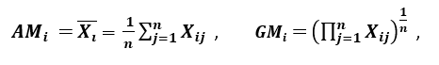

respectively; since **AMi ≥ GMi**, with equality holding if and only if **Xi1 = Xi2 = …. = Xin**, then the ratio



*can be used as a dispersion measure. Higher dispersion implies a higher value of Ri, thus a more relevant feature. Conversely, when all the feature samples have (roughly) the same value, Ri is close to 1, indicating a low relevance feature.’ [1]*

### **B. Wrapper Methods:**

Wrappers require some method to search the space of all possible subsets of features, assessing their quality by learning and evaluating a classifier with that feature subset. This feature selection process is based on a specific machine learning algorithm that we are trying to fit on a given dataset. It follows a greedy search approach by evaluating all the possible combinations of features against the evaluation criterion. The wrapper methods usually result in better predictive accuracy than filter methods.

**Wrapper feature selection** methods create many models with different subsets of input features and select those features that result in the best performing model according to a performance metric. These methods are unconcerned with the variable types, although they can be computationally expensive. Wrapper methods evaluate multiple models using procedures that add and/or remove predictors to find the optimal combination that maximizes model performance.

Let’s, discuss some of these techniques:

#### **Forward Feature Selection**

This is an iterative method wherein we start with the best performing variable against the target. Next, we select another variable that gives the best performance in combination with the first selected variable. This process continues until the preset criterion is achieved.

#### **Backward Feature Elimination**

This method works exactly opposite to the Forward Feature Selection method. Here, we start with all the features available and build a model. Next, we the variable from the model which gives the best evaluation measure value. This process is continued until the preset criterion is achieved.

This method along with the one discussed above is also known as the Sequential Feature Selection method.

#### **Exhaustive Feature Selection**

This is the most robust feature selection method covered so far. This is a brute-force evaluation of each feature subset. This means that it tries every possible combination of the variables and returns the best performing subset.

#### **Recursive Feature Elimination**

‘*Given an external estimator that assigns weights to features (e.g., the coefficients of a linear model), the goal of recursive feature elimination (RFE) is to select features by recursively considering smaller and smaller sets of features. First, the estimator is trained on the initial set of features and the importance of each feature is obtained either through a coef\_ attribute or through a feature\_importances\_ attribute.*

*Then, the least important features are pruned from the current set of features. That procedure is recursively repeated on the pruned set until the desired number of features to select is eventually reached.’[2]*

### **C. Embedded / Intrinsic Methods:**

These methods encompass the benefits of both the wrapper and filter methods, by including interactions of features but also maintaining reasonable computational cost. Embedded methods are iterative in the sense that takes care of each iteration of the model training process and carefully extracts those features which contribute the most to the training for a particular iteration.

Techniques for Embedded methods:

#### **LASSO Regularization (L1)**

Regularization consists of adding a penalty to the different parameters of the machine learning model to reduce the freedom of the model, i.e. to avoid over-fitting. In linear model regularization, the penalty is applied over the coefficients that multiply each of the predictors. From the different types of regularization, Lasso or L1 has the property that is able to shrink some of the coefficients to zero. Therefore, that feature can be removed from the model.

#### **Random Forest Importance**

Random Forests is a kind of a Bagging Algorithm that aggregates a specified number of decision trees. The tree-based strategies used by random forests naturally rank by how well they improve the purity of the node, or in other words a decrease in the impurity (**Gini impurity**) over all trees. Nodes with the greatest decrease in impurity happen at the start of the trees, while notes with the least decrease in impurity occur at the end of trees. Thus, by pruning trees below a particular node, we can create a subset of the most important features.

We can summarize feature selection as follows.

* Feature Selection: Select a subset of input features from the dataset.
  + Unsupervised: Do not use the target variable (e.g. remove redundant variables).
    - Correlation
  + Supervised: Use the target variable (e.g. remove irrelevant variables).
    - Wrapper: Search for well-performing subsets of features.
      * RFE

Filter: Select subsets of features based on their relationship with the target.

* + - * 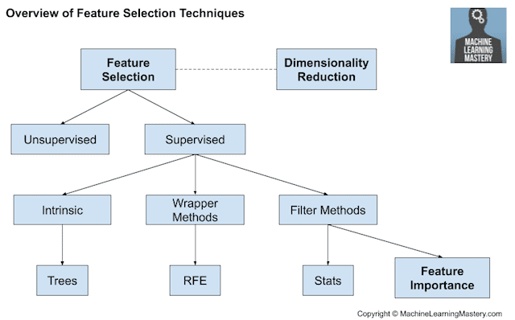Statistical Methods
      * Feature Importance Methods
    - **Embedded** : Algorithms that perform automatic feature selection during training.
      * Decision Trees

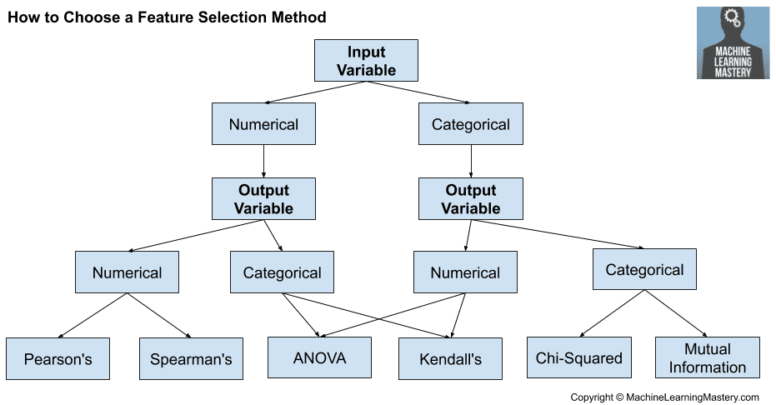

Common techniques:

Linear Regression: